*MOTOR: generate power for the propeller rotation to raise Quadrotor.
- Brush

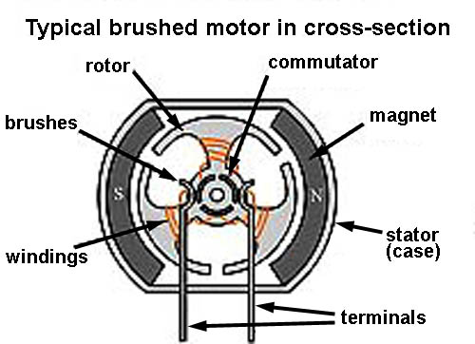
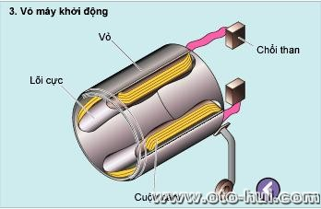

- Brushless:

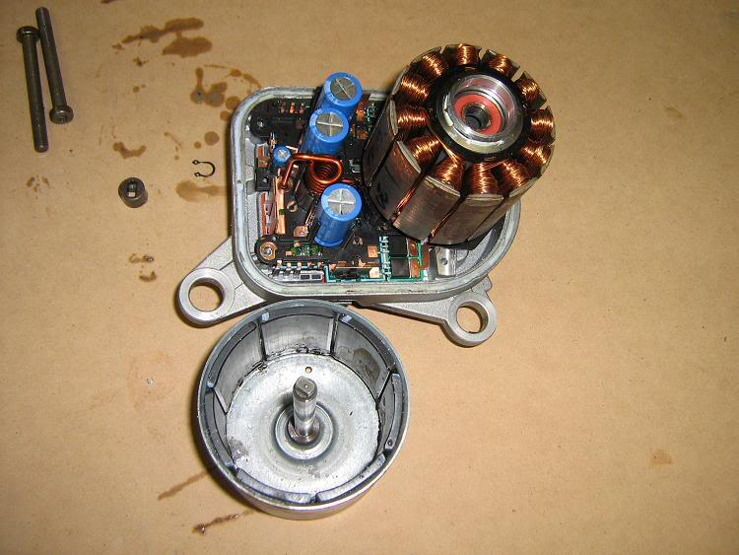

- Brush vs Brushless:
  - Brushless motors are often more efficient at converting electricity into mechanical power than brushed motors.
  - The maximum power that can be applied to a BL motor is exceptionally high, limited almost exclusively by heat, which can weaken the magnets.
  - more torque per watt (increased efficiency), increased reliability, reduced noise, longer lifetime (no brush and commutator erosion).

Motor Himodel A2212-10T 1400kv --- Price: 220k
Link: http://cholonhobby.com/may-bay-dieu-khien/Products/Detail/?tID=37&cID=648
Detail:
- No. Of cells:2-3 Li-Poly
- Max. efficiency current:6-18A (>75%)
- No load current / 10 V:0,7 A
- Dimensions:27.5x30 mm
- Shaft diameter: 3.17 mm
- Weight:47 g
- Recommend prop : 8x4,9x5
- Thrust : 800g +
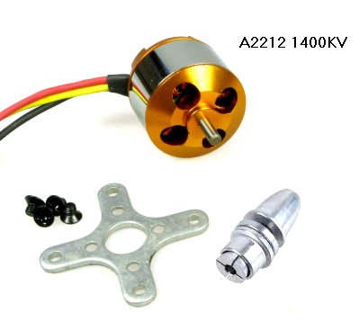

Explain:
- 1400kv or 1400RPM/V (RPM is revolutions per minute). Example:
  - Use power 1V for this: 1400 x 1 = 1400 revolutions/minute.
  - Use power 10V : 1400 x 10 = 14.000 revolutions/minute.
- Max. efficiency current: As the motor performance, the higher efficiency of energy is, the lower of energy loss. Will save battery for longer flight time.
- No load current / 10 V:0,7 A mean: if motor doesn’t work, power loss is 10V : 0,7A.
- Recommends Propeller : 8x4, 9x5:
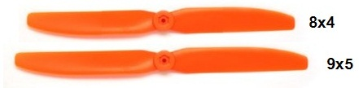

*ESC: the electronic speed controller is a device that regulates the amount of power that goes to the electric motor.

Esc HW 30A --- Price: 250k
Link: http://www.clbmohinh.com/forum/SKYTEAM-SHOPSALE-ESC-HW-30A_ESC-HIMODEL-10A_MOTOR-L%E1%BB%B0C-K%C3%89O-2KG-m562722.aspx
Detail:
- Weight: 22g (including wire)
- Max Current: 35A (for ten seconds)
- BEC: 2A at 5V
- Input: 2 - 3 Lipo

Explain:
- BEC: Battery Eliminator Circuit, decrease input from battery(11V) to 5V for ESC use. Similar as Ampe.

